**A Discussion of Herbaria**

with

**Dr. William Weber retired botany professor and curator emeritus of the Colorado University Museum of Natural History**

In this interview, Dr. Bill Weber discusses standards for herbaria organization, collecting methods, what to do with unknown plant species, and why recording accurate locations of plant species is important for understanding the distribution of plant species. He stresses the importance of specimen preservation and shares a brief history of herbaria, which includes the loss of monocot collections from the Vienna Museum during World War II. Dr. Weber also describes his background and the opportunities that took him across the U.S. collecting and identifying plants and eventually developing a nationally recognized herbarium at the University of Colorado in Boulder (CU Boulder) from acquired private botanical collections.

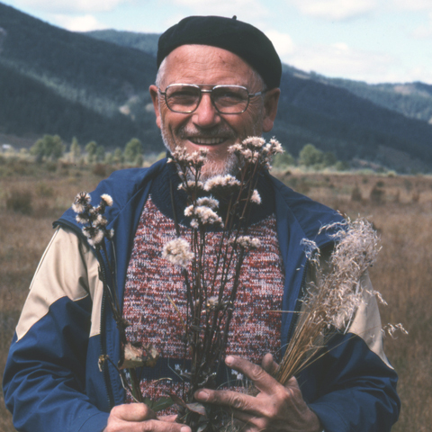

Dr. William Weber is a retired professor of botany and natural history at CU Boulder, curator emeritus of the Colorado University Museum of Natural History (CUMNH), and a Fellow of the Linnean Society of London. Along with Ron Wittmann, he has published many works in the Colorado Flora Series, most recently *Colorado Flora: Eastern Slope* (2012) and *Colorado Flora: Western Slope* (2012). Dr. Weber is also an accomplished bryologist and lichenologist. He authored *Bryophytes of Colorado: Mosses, Liverworts and Hornworts* with Ron Wittmann (2007) and *A Rocky Mountain Lichen Primer* with James Corbridge (1998). Dr. Weber developed hypotheses about the origin and distribution of alpine floras based on his world-wide botanical studies. As curator of the herbarium collection at CUMNH, Dr. Weber developed plant collections which today consist of more than half a million specimens. The collection was named the W.A. Weber Collection in 2012.

**References:**

Campbell, Mary Jane. 2014. Naturalist Weber honored for lifetime achievements. Colorado Arts and Sciences Magazine. <http://artsandsciences.colorado.edu/magazine/2014/10/naturalist-weber-honored-for-lifetime-achievements/> (accessed November 2015).