**Wetland Ratings on the National Wetland Plant List (NWPL)**

By Betsy Bultema and Jennifer Gillrich — USACE, ERDC-Cold Regions Research and Engineering Laboratory

This video discusses the history and definitions of indicator status ratings on the National Wetland Plant List (NWPL). A national list of plant species that occur in wetlands was developed in 1988 to support federal agencies in field identification of wetlands. In 2006, the US Army Corp of Engineers assumed responsibility over the list and it became known as the National Wetlands Plant List. Since then, the list has been updated with current plant name changes and indicator status ratings. Overall the list is meant to clarify the meaning of hydrophytic vegetation under the clean water act, the Wetland Conservation Provisions of the Food Security Act, and to serve in wetland restoration and creation projects. Each plant species on the NWPL has an indicator status which reflects the likelihood of presence in a wetland. The following are the accepted qualitative definitions of the five indicator status categories:

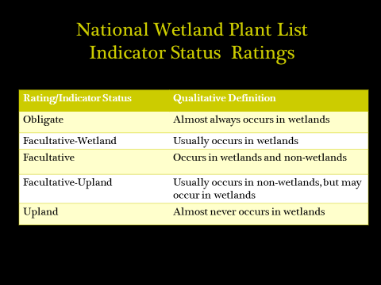

Species were placed in these categories based on a national and regional panel review process that included botanists and ecologists from the FWS, Army Corp, EPA, and NRCS.

Ratings were assigned to plant species separately within each of the ten Corp Wetland Delineation Regions (Figure 1). To inform these ratings the panels used best professional judgment and available literature, as well as feedback from universities, the private sector, and the public.

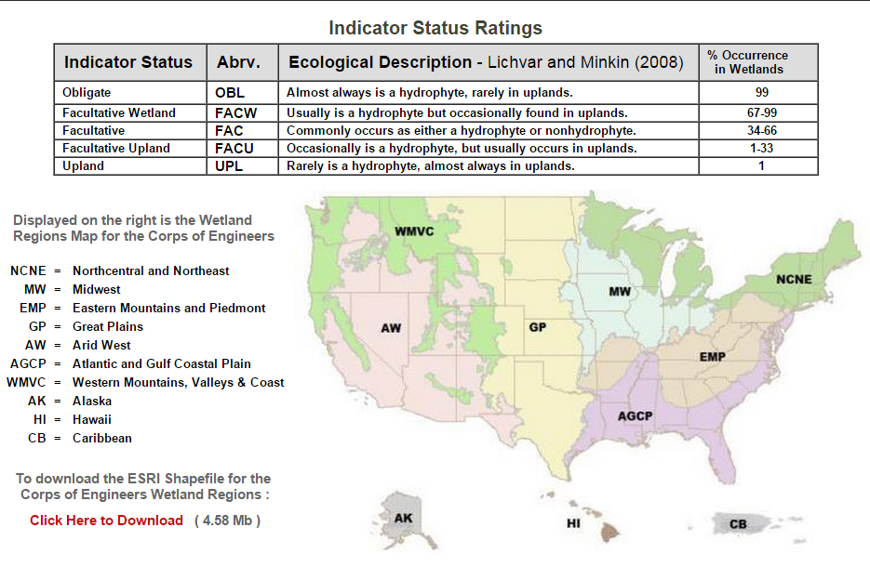Figure 1.

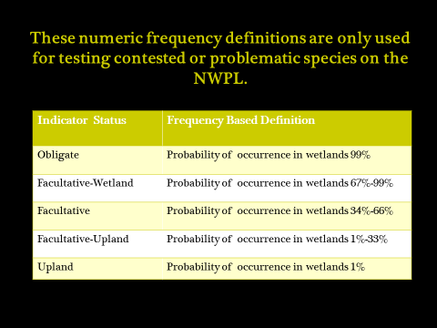Those familiar with the plant list may remember quantitative frequency based definitions for the indicator status categories:

We are using the newer, qualitative definitions rather than the quantitative definitions for all species on the NWPL. This is because a frequency definition alone implies that the wetland ratings were based on actual sampling of plant species populations, which is not the case for most plants on the NWPL. We are retaining the quantitative frequency based definition for any future challenge studies regarding the current accepted NWPL rating and for those species where field sampling has occurred and a frequency has been determined.

In the interview portion of this segment, we address in more detail the background of wetland plant ratings, how to look up species and their indicator status rating on the NWPL website, what to do if you disagree with a wetland rating, and additional commonly asked questions about the NWPL.

Some questions and answers from the interview include:

Why can’t I find a species on the NWPL? The NWPL is not an exhaustive list of all plant species that may be encountered in a wetland delineation. It only includes species that have been given an indicator status rating. If you are failing to find a plant species on the NWPL website, it may be the result of a spelling error. You may consider typing a portion of the genus name into the search bar and looking for the specific species this way.

How does the NWPL treat subspecies and varieties? What to do if I have only keyed to genus? The lowest taxa level wetland ratings are assigned to on the NWPL is species. Infraspecific taxa are not assigned wetland ratings. Thus, for the purposes of wetland delineation, there is no need to key past species. Indicator statuses are not assigned to genera on the NWPL. Thus, you will need to key to species for an indicator status. Fortunately, there is no effect on hydrophytic vegetation determinations if 80% rather than 100% of the vegetation cover is used for calculations. So if removing your unknown plant specimen from the sample retains at least 80% of the plot cover, you do not need to key it.