**What is Common?**

By Jennifer Gillrich — USACE, ERDC-Cold Regions Research and Engineering Laboratory

This video explains the recently posted lists of the ten most common wetland plant families in the nation, the Corps wetland regions, the states, and the Corps Regulatory Districts. As this series progresses, dichotomous keys to the species on these lists will be posted for each region. The National Wetland Plant List (NWPL) database contains a record of each species’ presence or absence, for each county in the United States. Families, genera, and species present in more than half of the counties in a geographic area were considered common. Commonness varied with spatial scale (Figure 1). Kentucky Blue Grass(*Poa pratensis*) is common nationally, but not in all regions. It was not common in the

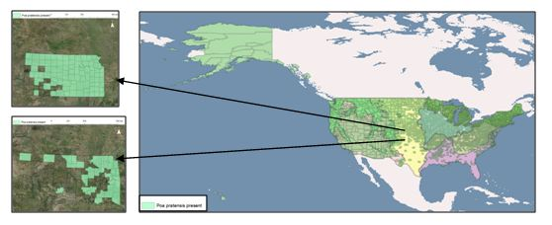

**Figure 1. A common species *Poa pratensis* (Kentucky Blue Grass), is present in more than half the counties in the United States. It is present in less than half the counties in the Atlantic and Gulf Coastal Plain region and Oklahoma.**

Atlantic and Gulf Coastal Plain, Hawaii, and the Caribbean. At the state level, Kentucky Blue Grass may be common or not, as in Kansas and adjacent Oklahoma, respectively. In small states with very few counties, such as Delaware, only the species present in all counties were considered common.

Species from large families, such as the grasses, asters, and sedges, were more likely than those from smaller families to be considered common. Yet, species from small families with very few species on the NWPL, such asBoxelder(*Acer negundo*), may still occur in more than half the counties in the nation (Figure 2). Regional keys to special plant groups, such as woody plants or ferns, will address this type of common species.

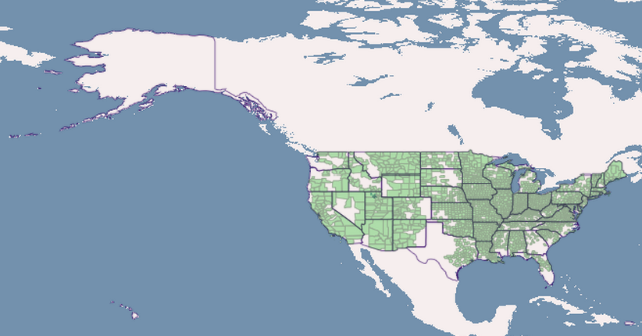

**Figure 2. Boxelder(*Acer negundo*) is common, occurring in more than half the counties in the nation. It is not on the lists because it comes from a small family with few species on the National Wetland Plant List.**