**The Natural History of Ferns** with **Paul Wolf, Professor, Utah State University**

Episode 2a of All Things Wetland Plants is the first part of an interview with Paul Wolf. He discusses the natural history of ferns, including evolution, distribution, phylogeny, and lifecycle. The second part, Episode 2b, will focus on key features used to identify ferns.

**What is a Fern?**

There is no single characteristic that is unique to ferns, except that they all share a common ancestor about 350 million years old. Ferns reproduce by spores and have true leaves that originate from a coiled fiddlehead (Figure 1). Fiddleheads of certain species, such as ostrich fern (*Matteuccia struthiopteris*), are edible. Others, such as the bracken ferns (*Pteridium* spp.), are toxic when eaten in large quantities.

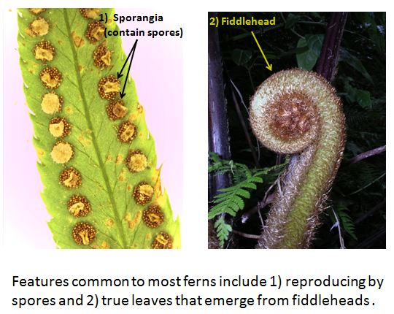 

**Figure 1. Features common to most ferns include 1) reproducing by spores, and 2) true leaves that emerge from coiled fiddleheads.**

Many ferns also have rhizomes, underground stems that produce roots and fronds. In terrestrial ferns, rhizome structure influences growth form, making plants appear either clumped or scattered (Figure 2). Another growth form is that of epiphytic ferns, which grow on top of other plants. Adaptations such as leaf scales help them absorb water and nutrients. Epiphytic ferns are most common in tropical

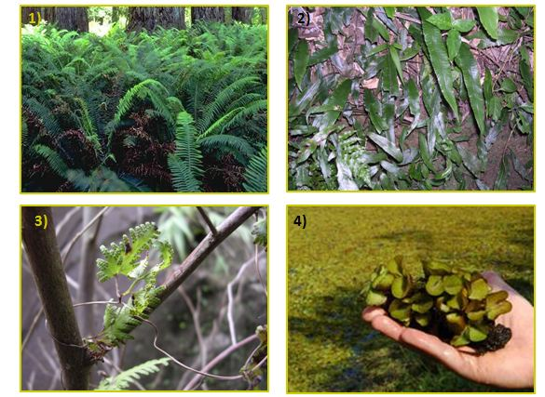

**Figure 2. Some fern growth forms: 1) clumped,** *Polystichum munitum***; 2) creeping or scattered,** *Diplazium subsinuatum*; **3) epiphytic,** *Lygodium japonicum***; and 4) aquatic,** *Salvinia molesta***.**

rainforests and cloud forests, but some occur in the U.S. (i.e. *Polypodium* spp.). Aquatic ferns, which float or root in standing water, represent a fourth growth form. Many of these do not look like ferns, but when examined closely, true leaves that develop from a coiled fiddlehead are visible. Ferns also contain pigments that enable them to photosynthesize under the low light conditions common in forest understories, both temperate and tropical. Most ferns are fairly long lived perennials. Tropical tree ferns can live 30 — 40 years. However, some aquatic species have shorter life spans.

**Evolution**

Ferns first occur in the fossil record in the Carboniferous Period (300 — 250 million ybp). But, most ferns (80%) trace their origins to the Cretaceous Period (100 — 200 million ybp) that ended with a mass extinction event. This event may have been caused by an asteroid-earth collision that filled the atmosphere with dust and ash, blocking sunlight for months or years. The fossil record suggests that the ferns that survived quickly colonized the earth and were quite abundant when compared to the flowering plants that survived. Today there are an estimated 12,000 — 15,000 fern species worldwide, but only 9,000 have been described and named.

**Distribution**

Ferns are most diverse in the Tropics and southeast Asia. In the U.S., the east probably has a larger number of fern species, but the west has greater fern abundance and biomass. Ferns grow in many different habitats, including deserts, alpine areas, rainforests, cloud forests, and in aquatic settings. Habitat preference is species specific, but the majority of ferns occur in uplands. Most ferns prefer mesic habitats with well-drained, oxygenated soils. However, there are a few wetland species that tolerate boggy, waterlogged soils. However, a group of related plants, the horsetails(*Equisetum* spp.), are more likely to occur in wetlands.

**DNA-Phylogeny**

Genetic analyses have resolved many questions regarding evolutionary relationships among fern taxa. Although this work has revealed many strong character traits that define small subgroups, field identification can still be difficult. For instance, the largest fern family, the Dryopteridaceae (Wood Fern Family), has no single character that defines it. Dichotomous keys eliminate all the other fern families, before arriving at this family. The same is true of the genus Dryopteris.

In ferns, chloroplast genes were first used for DNA sequencing. Now, scientists are sequencing the entire genome. Like flowering plants, ferns frequently double their chromosome counts (ploidy levels) when reproducing. One Himalayan species has more than 1,400 chromosomes. In ferns, as the number of chromosomes increases, genome size also increases. This is not true of all plants, however. A typical fern genome may be three to five (to ten) times as large as a human genome.

**Fern Lifecycle**

Ferns reproduce by spores which are haploid (half the chromosomes of the parent plant), as are animal gametes, egg and sperm. Unlike animal gametes, fern spores do not immediately combine to produce a new diploid individual (Figure 3). Spores have ridges and flaps to catch the wind for dispersal. When a

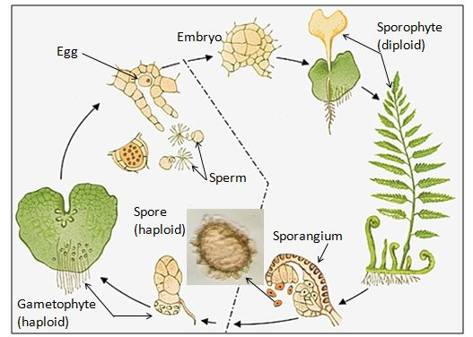

**Figure 3. Fern life cycle alternates between the diploid sporophyte and the haploid gametophyte, an independent sexual stage that produces gametes (sperm, egg).**

spore lands in a suitable habitat; it grows into a haploid gametophyte, several mm long. The gametophyte produces gametes (eggs, sperm). Sperm swim though soil moisture to fertilize an egg. They unite to form a diploid embryo that grows into a fern.

If you have questions about ferns, email us at [nwpl@usace.army.mil](mailto:nwpl@usace.army.mil)